Repository URL: https://github.com/YourUsername/SmartLibrary-GroupX

Tag name: week4-submission

Submitted files:

- operations.py

- demo.py

- tests.py

- README.md

- UML.pdf

- DesignRationale.pdf

- submission.txt

Successful login and menu use:

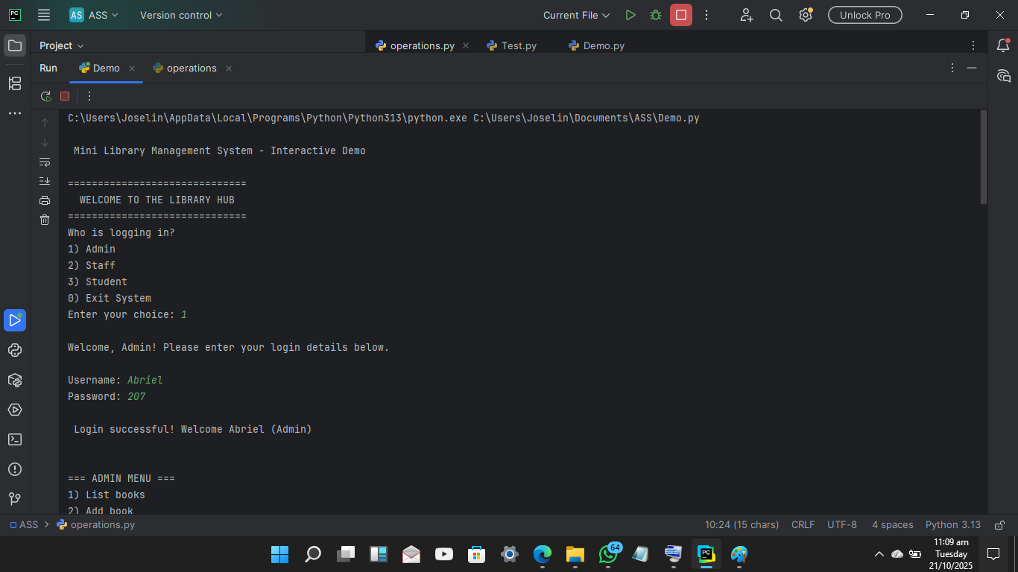

Borrow/return actions:

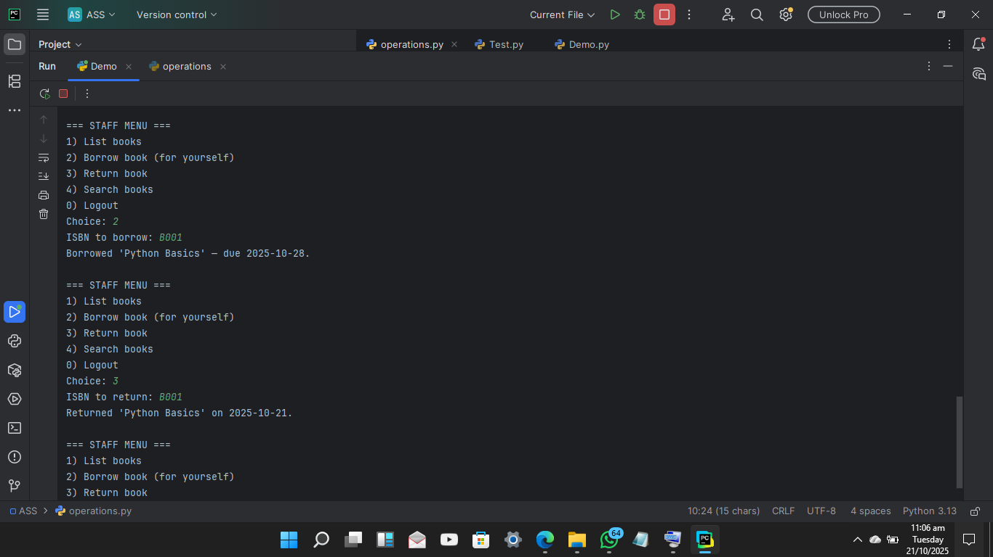

Tests passed terminal output:

